Multimedia Development Lab 1
ADOBE PHOTOSHOP
WEEK_03

Using the Photoshop CS5 Content Aware Spot Healing Brush
Simply choose the Spot Healing Brush from the toolbox and make sure, in the Options bar, see that Content Aware feature is checked. (Its a little radio button.). Then just make a brush stroke over any area you want to remove. There will be a slight delay while Photoshop does its calculations, but the results are amazing.
The Spot Healing Brush is selected, and the Content Aware button has been chosen.

Here’s a picture I took of Yankee Stadium. Note the offending power line just above the stadium. Normally not too hard to remove, but the clouds complicate matters. Photograph © Gary Small
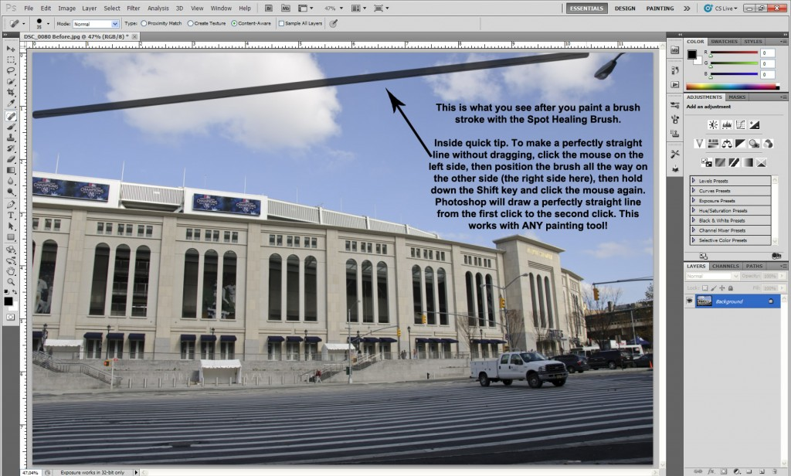
Note the dark line that results from making a brush stroke with the Spot Healing Brush. Depending on the size of the brush stroke and the size and resolution of the image, this may remain for a few to several seconds while Photoshop calculates a pattern to replace the area with. Note: the “Click…Shift-Click” method was used to make a perfectly straight line.

Here’s the end result. If you compare the Before to the After, you’ll see the light fixture in the top right was also removed. I used the Content Aware Spot Healing Brush on that too! And for good measure, I also used the Lasso Tool and Content Aware Fill to remove the truck parked in front of the stadium. If you look closely, you’ll see it’s not exactly perfect.

Exercise: Try yourself with the given demo images.

